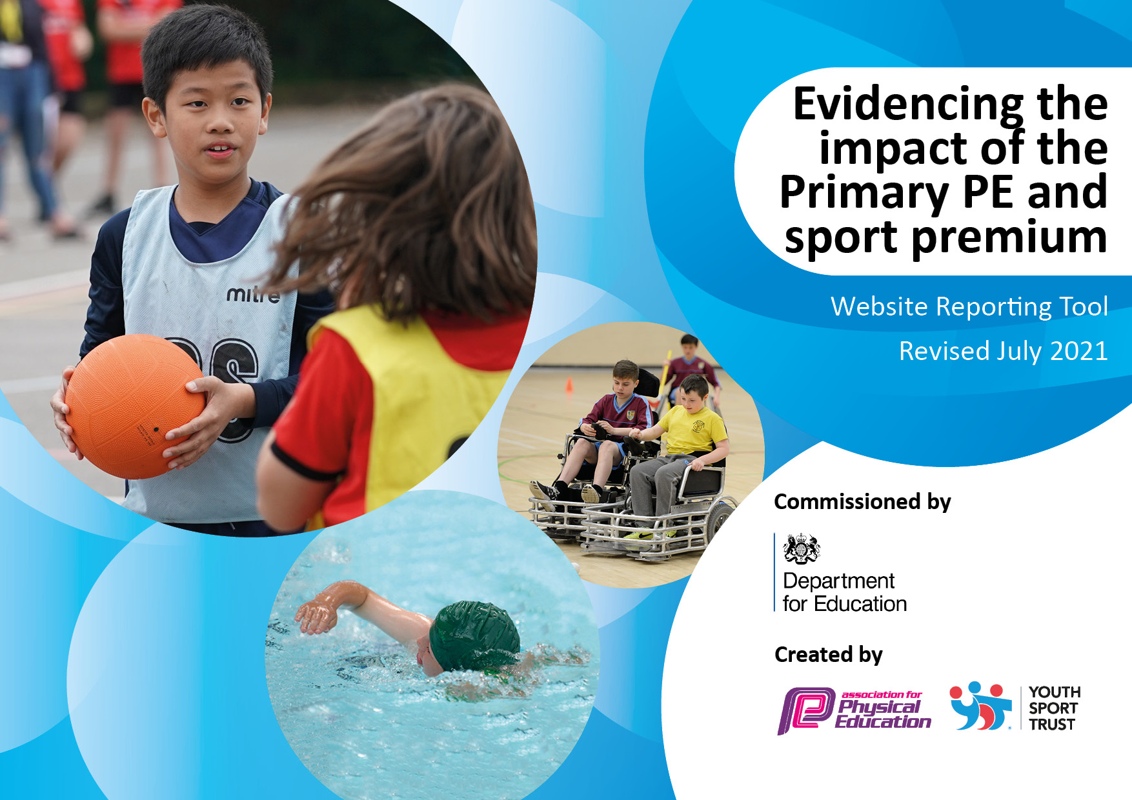
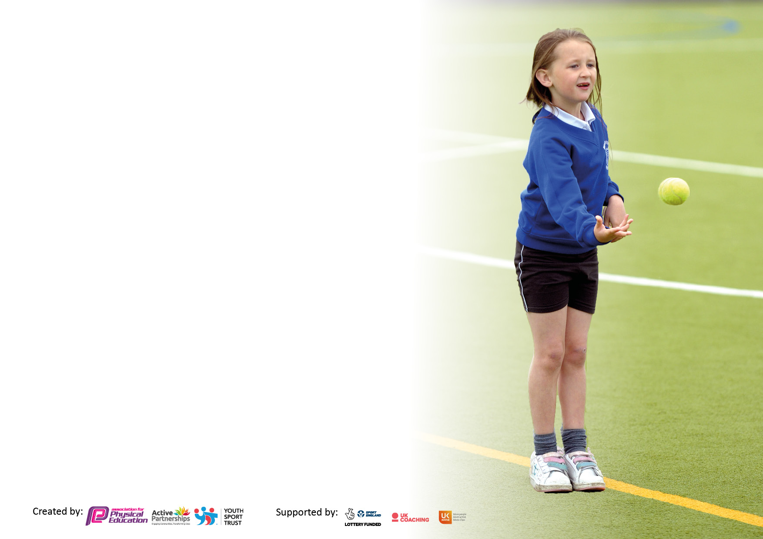

It is important that your grant is used effectively and based on school need. The Education Inspection Framework makes clear there will be a focus on ‘whether leaders and those responsible for governors all understand their respective roles and perform these in a way that enhances the effectiveness of the school’.

Under the Quality of Education Ofsted inspectors consider:
Intent - Curriculum design, coverage and appropriateness
Implementation - Curriculum delivery, Teaching (pedagogy) and Assessment
Impact - Attainment and progress

To assist schools with common transferable language this template has been developed to utilise the same three headings which should make your plans easily transferable between working documents.

Schools must use the funding to make additional and sustainable improvements to the quality of Physical Education, School Sport and Physical Activity (PESSPA) they offer. This means that you should use the Primary PE and sport premium to:

- Develop or add to the PESSPA activities that your school already offer
- Build capacity and capability within the school to ensure that improvements made now will benefit pupils joining the school in future years
- The Primary PE and sport premium should not be used to fund capital spend projects; the school’s budget should fund these.

Pleasevisitgov.ukfortherevisedDfEguidanceincludingthe5keyindicatorsacrosswhichschoolsshoulddemonstrate animprovement.Thisdocumentwillhelpyoutoreviewyourprovisionandtoreportyourspend.DfEencouragesschools to use this template as an effective way of meeting the reporting requirements of the Primary PE and sport premium.

We recommend you start by reflecting on the impact of current provision and reviewing the previous spend.

Schools are required to publish details of how they spend this funding, including any under-spend from 2019/2020, as well as on the impact it has on pupils’ PE and sport participation and attainment. All funding must be spent by 31st July 2022.

We recommend regularly updating the table and publishing it on your website throughout the year. This evidences your ongoing self-evaluation of how you are using the funding to secure maximum, sustainable impact. Final copy must be posted on your website by the end of the academic year and no later than the 31st July 2021. To see an example of how to complete the table please click HERE.
Created by: Supported by:

Details with regard to funding
Please complete the table below.

Total amount carried over from 2019/20 | £0
Total amount allocated for 2020/21 | £0
How much (if any) do you intend to carry over from this total fund into 2021/22? | £0
Total amount allocated for 2021/22 | £21,578
Total amount of funding for 2021/22. To be spent and reported on by 31st July 2022. | £21.578
Swimming Data
Please report on your Swimming Data below.

Meeting national curriculum requirements for swimming and water safety.  N.B. Complete this section to your best ability. For example you might have practised safe self-rescue techniques on dry land which you can then transfer to the pool when school swimming restarts.  Due to exceptional circumstances priority should be given to ensuring that pupils can perform safe self rescue even if they do not fully meet the first two requirements of the NC programme of study | Not applicable
What percentage of your current Year 6 cohort swim competently, confidently and proficiently over a distance of at least 25 metres?  N.B. Even though your pupils may swim in another year please report on their attainment on leaving primary school at the end of the summer term 2021.  Please see note above | Not applicable
What percentage of your current Year 6 cohort use a range of strokes effectively [for example, front crawl, backstroke and breaststroke]?  Please see note above | Not applicable
What percentage of your current Year 6 cohort perform safe self-rescue in different water-based situations? | Not applicable
Schools can choose to use the Primary PE and sport premium to provide additional provision for swimming but this must be for activity over and above the national curriculum requirements. Have you used it in this way? | Not applicable

Action Plan and Budget Tracking
Capture your intended annual spend against the 5 key indicators. Clarify the success criteria and evidence of impact that you intend to measure to evaluate for pupils today and for the future.

Academic Year: 2021/22 | Total fund allocated: £21,578 | Date Updated: 24.07.2022
Key indicator 1: The engagement of all pupils in regular physical activity – Chief Medical Officers guidelines recommend that primary school pupils undertake at least 30 minutes of physical activity a day in school |  |  |  | Total fund allocated :  £21,578
Intent | Implementation |  | Impact
Your school focus should be clear what you want the pupils to know and be able to do and about  what they need to learn and to  consolidate through practice: | Make sure your actions to achieve are linked to your intentions: | Funding allocated: | Evidence of impact: what do pupils now know and what can they now do? What has changed?: | Sustainability and suggested next steps:
All children will have 2 PE lessons a week  All children encouraged to increase their fitness through inter-house and external competitions (St Helens school games).  Staff will engage children in physical activity during break and lunch times through the use of the new multisports markings on the playground.  Encourage children to cycle to school and provide bike racks for safe storage.  Extend the trim trail to encourage more children to use it. | Sequenced lessons delivered to children using ‘Get Set 4 PE’.  Inter-house/external sporting tournaments/competitions throughout the year.  Following whole school CPD, staff are equipped to use the new multisports markings on the playground to maximum effect  Bike rack to be fitted  More children will be able to use | Resources and storage  £15,000 | Children at school enjoy physical activity and are engaged in many activities throughout the school day.  PE lessons, playtimes, lunchtimes and extra-curricular activities ensure most of the children get opportunities to participate in at least 30 minutes of physical activity a day.  As a result the children’s fitness and engagement has increased this year  External and internal competitions have been organised through SHSG as well as sports days within school and as a result children have engaged in more competitive sports.  More children are cycling and scootering to school so increasing further their levels of physical activity | We will continue to use the ‘Get Set 4 PE’ resources and lesson plans linked to the national curriculum (NC)  In order to enhance the provision of PE and improve physical activity more outdoor resources and indoor resources will be purchased to enrich the provision even further.  Specialist coaching provision will also be enhanced with a dance and gymnastic company and multi-skills coaching involvement in teaching and training staff throughout the year.  More structured lunchtime provision will be enhanced with further training for MDAs
Key indicator 2: The profile of PESSPA being raised across the school as a tool for whole school improvement |  |  |  | Total fund allocated :  £21,578
Intent | Implementation |  | Impact
Your school focus should be clear what you want the pupils to know and be able to do and about  what they need to learn and to  consolidate through practice: | Make sure your actions to achieve are linked to your intentions: | Funding allocated: | Evidence of impact: what do pupils now know and what can they now do? What has changed?: | Sustainability and suggested next steps:
To raise the profile of sporting activities, achievements and experiences to parents, carers and the local community.  Sports ambassadors gain pupil voice to feed into future activities, experiences and clubs.  Ensure all children are aware of the importance of a healthy lifestyle, including both diet and regular exercise. | Promote through school newsletter. Celebrate in assemblies.  PE subject leader supports the sports ambassadors in gaining pupil voice and analysis of views.  Introduce a healthy eating week and ensure links across the curriculum are clear to children. | £300 supply costs for subject leader cover | Children in school know that to be healthy you must do physical activity/sport to help you.  The children know about how to warm up for sport and why you need to do this.  The children’s enthusiasm and passion for engaging in clubs both in and out of school has been very encouraging this academic year. | The profile of PESSPA will be raised considerably next academic year with the introduction of more specialist coaches to work alongside teachers and MDAs, senior leaders, governors and parents.

Key indicator 3: Increased confidence, knowledge and skills of all staff in teaching PE and sport |  |  |  | Total fund allocated :  £21,578
Intent | Implementation |  | Impact
Your school focus should be clear | Make sure your actions to | Funding | Evidence of impact: what do | Sustainability and suggested
what you want the pupils to know | achieve are linked to your | allocated: | pupils now know and what | next steps:
and be able to do and about | intentions: |  | can they now do? What has
what they need to learn and to |  |  | changed?:
consolidate through practice:
Staff will engage children in physical activity during break and lunch times through the use of the new multisports markings on the playground  Provide ‘Teach Active’ for teachers to deliver PE related sessions in Maths and English lessons.  To provide staff with high-quality resources to help ensure delivery of the school scheme is consistent across school. | Following whole school CPD, staff are equipped to use the new multi-sports markings on the playground to maximum effect.  Linking physical activity to Maths and English concepts.  PE lead to work alongside staff with planning high-quality sessions using the progression map. | £500  £1000 | All teaching staff have increased confidence as a result of the ‘Get Set 4 PE’ resources used and have led an extra-curricular activity this year.  Consequently, more staff have been involved in PESSPA provision and therefore more children have been engaged in physical activities each and every day. | With increased numbers of sports specialists working alongside staff, as well as further whole school CPD for staff, then their confidence, knowledge and skills will increase and as a result, children’s outcomes will improve.
Key indicator 4: Broader experience of a range of sports and activities offered to all pupils |  |  |  | Total fund allocated :  £21,578
Intent | Implementation |  | Impact
Your school focus should be clear | Make sure your actions to | Funding | Evidence of impact: what do | Sustainability and suggested
what you want the pupils to know | achieve are linked to your | allocated: | pupils now know and what | next steps:
and be able to do and about | intentions: |  | can they now do? What has
what they need to learn and to |  |  | changed?:
consolidate through practice:
Support and involve the least active children by providing targeted activities and running school sports clubs.  Introduce local sports to children.  Use sports specialists to deliver particular elements of the national curriculum to fulfil yearly objectives. | Encourage attendance of this group of children at various clubs of interest to them.  Local sports coaches to deliver taster sessions to children within the school day and clubs afterschool.  Children provided with sessions of gymnastics and dance. | £815  £4,860 | Some specific groups of children have been targeted to ensure they have had the opportunity to participate in extra-curricular activities this year. This strategy has worked well and more children than ever have seized these opportunities. As a result there has been  - improved physical and mental wellbeing.  - More children achieved age-related expectations.  - Children had a wider experience of accessible sports | New clubs and new activities will be introduced next academic year, both during curriculum lessons as well as before and after school clubs.  Improved links will be made with local clubs in order to increase opportunities children have of joining these clubs and developing their confidence, knowledge and skills.

Key indicator 5: Increased participation in competitive sport |  |  |  | Total fund allocated :  £21,578
Intent | Implementation |  | Impact
Your school focus should be clear | Make sure your actions to | Funding | Evidence of impact: what do | Sustainability and suggested
what you want the pupils to know | achieve are linked to your | allocated: | pupils now know and what | next steps:
and be able to do and about | intentions: |  | can they now do? What has
what they need to learn and to |  |  | changed?:
consolidate through practice:
All children encouraged to increase their fitness through inter-house competitions.  All children encouraged to increase their fitness through external competitions (St Helens school games) | Inter-house sporting competitions throughout the year.  Attend external sporting competitions throughout the year when available. Transport provided | £720 | Children have participated in externally organised competitions as well as internal competitions, for example sports days.  As a result they get to demonstrate their talents and skills and experience, sometimes for the first time, a competitive sporting situation. | Further opportunities for competitive sporting situations will be explored with St Helens School Games and other local schools.  Internal sports days will continue and some intra-school competitions will be developed throughout the next academic year.

Signed off by
Exec Head Teacher: | John Daley
Date: | 18th July 2022
Subject Leader: | Hayley Bailey/John Daley
Date: | 18th July 2022
Governor: | Vanessa Wells
Date: | 24th July 2022

